**CS 325 - Analysis of Algorithms**

**March 16, 2017**

**Group members:** Eric Stevens, Jong Park, Zhenggan Zheng

Programming Assignment 3

# Warm-Up: Least Squares, Not Good Enough

* **Linear Program for General Problem**

Let: $Z=max_{i = 1→n}^{}[abs({ a*x}_{i} + b - y_{i} )]$

Objective: $min( Z )$

Constraints: $for( i in range 1:n)\{$

${ a*x}_{i} + b - y_{i} ≤ Z$

${ a*x}_{i} + b - y_{i} ≥ -Z$

$\}$

* **Solution to Specific Problem**

$Y=(1.7142857)*X + (1.8571429)$

* **Output of Linear Solver**

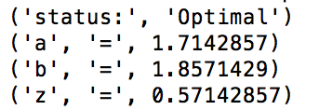

* **Plot of Warm-Up Data and Linear Average**

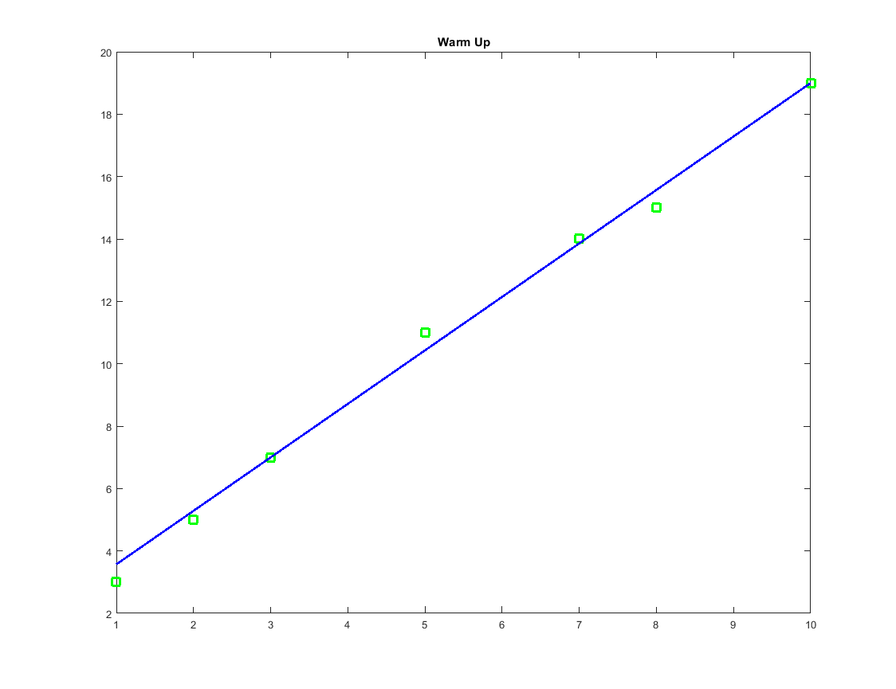

# Warming-Up: Local Temperature Corvallis

* **Description of the Linear Program**

This program uses the same methodology as the “warm-up” program above. It uses the same “minimization of the maximum absolute deviation” technique as “warm-up”. The difference is that the “warm-up” problem only had two initial variables, the “local temperature” problem has six variables. While actual definitions of what these variables are supposed to represent have not been provided to us, based on the results of our linear modeling we have drawn conclusions about what they represent.

* **X0:** This variable represents the average temperature in general at the time of the first day of data collection.
* **X1:** This variable represents the long term warming trend. It is meant to stand for the amount of temperature change per day. One way to look at this value is to consider it the average rate at which global warming is occurring day by day.
* **X2 & X3:** These two values are phasor magnitudes together represent the variation of temperature over the course of a year due to seasons. Two phasor magnitudes are needed, a sine and a cosine, in order to make the result of the sum of the phasors independent of the day that the record started. Only their combined magnitudes are significant.
* **X4 & X5:** These two values are phasor magnitudes together represent the variation of temperature over the course of a solar cycle.

These variables are fed into a very similar linear programming model as before, except the the constraint functions are much more complex.

Let:

$day[i] = index value of day$,

$T[i] =Temperature on day[i]$, $Z=max_{i = 1→n}^{}[abs({ x}_{0}+{ x}_{1}*day[i] +{ x}_{2}cos(\frac{2π*day[i]}{365.25})+{ x}_{3}sin(\frac{2π*day[i]}{365.25})+{ x}_{4}cos(\frac{2π*day[i]}{365.25*10.7})+{ x}_{5}sin(\frac{2π*day[i]}{365.25*10.7}) - T[i] )]$

Objective: $min( Z )$

Constraints: $for( i in range 1:n)\{$

${ x}_{0}+{ x}_{1}*day[i] +{ x}_{2}cos(\frac{2π*day[i]}{365.25})+{ x}_{3}sin(\frac{2π*day[i]}{365.25})+{ x}_{4}cos(\frac{2π*day[i]}{365.25*10.7})+{ x}_{5}sin(\frac{2π*day[i]}{365.25*10.7}) - T[i] ≤ Z$

${ x}_{0}+{ x}_{1}*day[i] +{ x}_{2}cos(\frac{2π*day[i]}{365.25})+{ x}_{3}sin(\frac{2π*day[i]}{365.25})+{ x}_{4}cos(\frac{2π*day[i]}{365.25*10.7})+{ x}_{5}sin(\frac{2π*day[i]}{365.25*10.7}) - T[i] ≥ -Z$

* **Solutions to Linear Program From Corvallis Data**

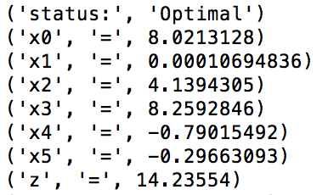

* **Plot of Raw Data and Linear Average**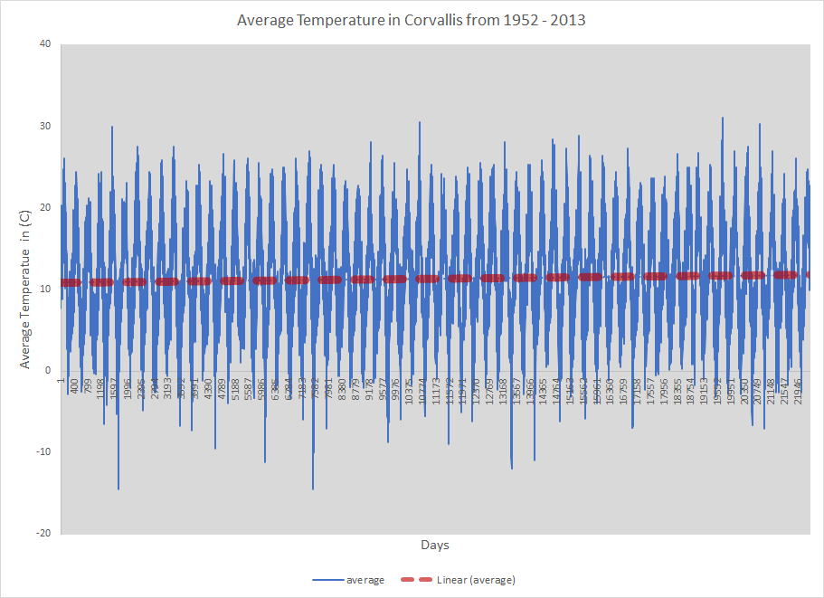
* **Rate of Change over a Century**

As can been seen in the from the results above, our x0 value is a positive value. This means that there is a general **long term warming trend**. This value represents the average amount that the earth is warming up per day over the course of the dataset. In order to figure out how much the this trend would project out over the course of a century we must preform some simple algebra.

$Let x1 be the amount of temperature change that occurs per day$

$Let CD be the amount of temperature change that occurs per over a century$

$CD = x1*(\frac{degrees C}{day}) * (\frac{days}{year}) * (\frac{years}{century})$

$CD = 0.0001069*(\frac{degrees C}{day}) * (\frac{365.25*days}{year}) * (\frac{100 * years}{century})$

$CD = 3.905*(\frac{degrees C}{century})$

# 

# Bonus: San Diego

* **Description of Linear Program**

The description of this linear program is exactly the same as the one for the Corvallis program. It uses the same code. This project has made us worry so much about global warming that we would prefer to refer you to the above descriptions rather than copy and paste the explanation above, thus conserving electron and holes in memory.

* **Solution to Linear Program for San Diego Data**

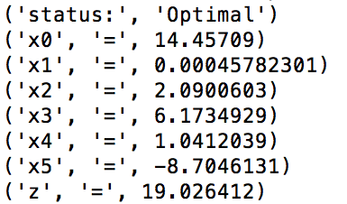

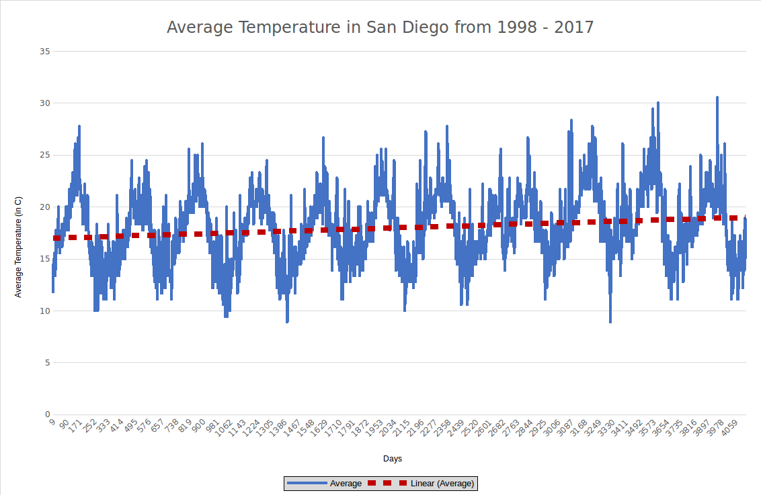

* **Plot of Raw Data and Linear Average for San Diego**
* **Rate of Change over a Century**

As can been seen in the from the results above, our x0 value is a positive value. This means that there is a general **long term warming trend**.

$Let x1 be the amount of temperature change that occurs per day$

$Let CD be the amount of temperature change that occurs per over a century$

$CD = x1*(\frac{degrees C}{day}) * (\frac{days}{year}) * (\frac{years}{century})$

$CD = 0.000458*(\frac{degrees C}{day}) * (\frac{365.25*days}{year}) * (\frac{100 * years}{century})$

$CD = 16.73*(\frac{degrees C}{century})$

* **Interesting Observations About San Diego Data**

We as a team requested 50 years worth of San Diego data. We were repeatedly only provided with data from 1998 until the present. While this is unfortunate and results in an increased margin of error for the linear result, it also has some interesting implications. Let's assume for the moment that the algorithm is as accurate for 20 year data as it is for 50 year data. This means that the shorter and more recent period of time one looks at the steeper average rate of temperature increase line is. This implies that **the rate of average temperature increase is increasing!**